Game Design Document

Fill up the following document

1. Write the title of your project.

Alien Shooter

1. What is the goal of the game?

The goal of the game is to defeat the aliens and reach Earth safely.

1. Write a brief story of your game.

You are left behind by your team members in space. There are a lot of

Aliens trying to kill you. You have to escape and kill the aliens attacking you

And reach Earth safely. You will have 3 chances to escape and kill the

Aliens. The game will end if you die.

1. Which are the playing characters of this game?

* Playing characters are the ones who respond to the user based on the input from the user.
* Cars, monkeys, dinos, wizards, etc., are the playing characters in the game.

|  |  |  |
| --- | --- | --- |
| Number | Character Name | What can this character do? |
| 1 | Space Ship | Will shoot the aliens and destroy them |
| 2 | Aliens | Will try to kill the Space Ship |
| 3 |  |  |
| 4 |  |  |
| 5 |  |  |
| 6 |  |  |
| 7 |  |  |
| 8 |  |  |

1. Which are the Non-Playing Characters of this game?

* Non-Playing characters are the ones that don't have an action or behavior when the user interacts with the game.
* Hurdles, stones, bananas, coins, etc., are non-playing characters in the game.

|  |  |  |
| --- | --- | --- |
| Number | Character Name | What can this character do? |
| 1 | Fuel | To give energy to the SpaceShip |
| 2 |  |  |
| 3 |  |  |
| 4 |  |  |
| 5 |  |  |
| 6 |  |  |
| 7 |  |  |
| 8 |  |  |

Draw your imagination of this game. What does this game look like?

* Draw the game either on your computer or on paper.
* Add images of the game scenes to show each of the playing and non-playing characters at least once.

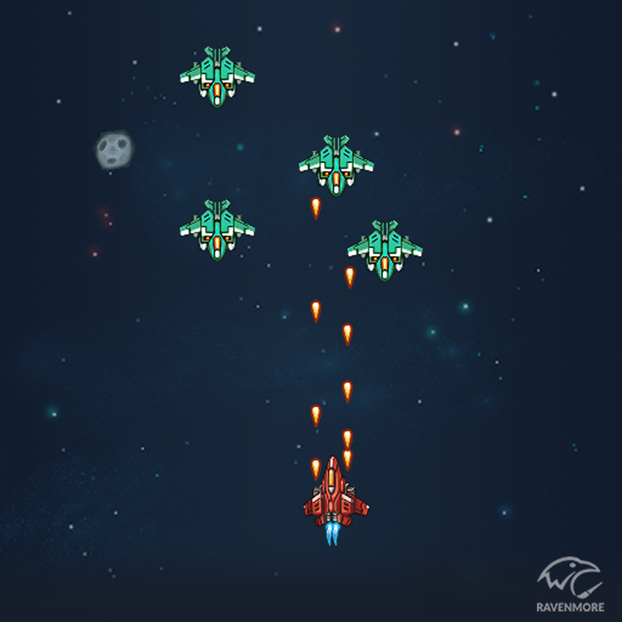

How do you plan to make your game engaging?

The Speed of the aliens increase after a certain point and aliens will start

Attackng at the spaceShip.